**SHOPNEST STORE DETAILED REPORT**

***Purpose***:

To address Key Business Indicators for ShopNest through visualization containing key findings.

***Assumptions***:

1. **Revenue**= “price” **\*** quantity(“order_item_id”) **+** “freight_value” *from* “order_items_dataset” table.
2. **Sales** = sum of “payment_value” *from* “Order_payments_dataset”.
3. “Product_category_name_English” has been taken in place of Portugese names from “Product_category_name” table for better understanding.
4. Pictures can be zoomed in Report file(word file) as Data labels font size has been kept so as to keep better visualization in PowerBI dashboard which contains around 10 charts/tables.

***Navigation***

1. Slicers have been provided for Year, Quarter, Month, States and Product categories for navigation and specific drilling down of figures.
2. Business Impact in Detailed Report mentions solutions alongwith impact.

***Dashboard***

1. **Top Categories by Total Price:**

**Question 1**: Identify and visually represent the top 10 product categories by total sales.

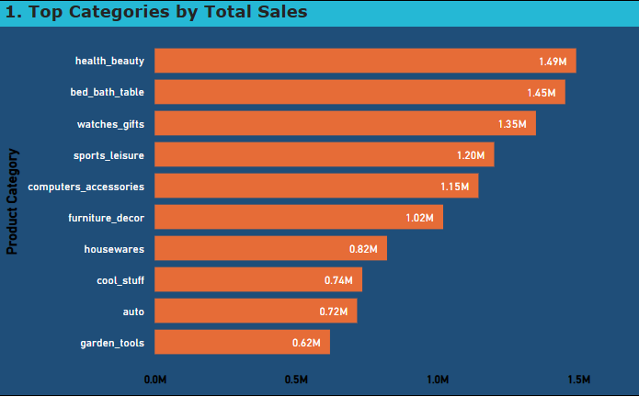

***Explanation****:* Chart represents Top categories by total sales occurred from 2016-18.

***Insights****:* ﻿

* At 1.5 million health_beauty products had the highest Total Sales which accounted for 14% of total sales.

***Business Impact****:*

* Out of 72 distinct product categories, above mentioned top 10 category accounts for 58% of total sales (9.8M/16.81M). Thus, supply of these products shall be ensured on priority basis.

1. **Delayed Orders Analysis:**

**Question 2**: Determine the number of delayed orders in each category. An order is considered delayed if the actual delivery date is later than the estimated delivery date.

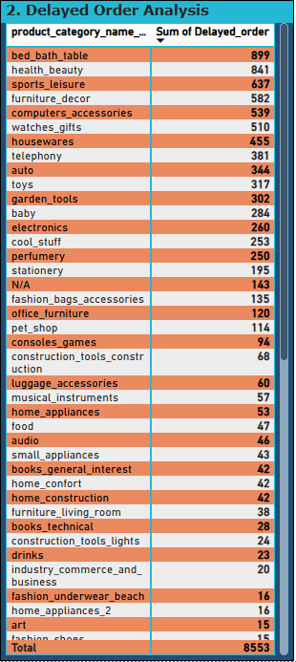

***Explanation****:* Table represents category-wise delayed order analysis

***Insights****:*

* 143 delayed orders doesn’t fall under any category.
* 4 categories have none delayed orders.
* Category “bed_bath_table” and “health_beauty” are some of the highest delayed orders(20%).
* While top 10 categories account for 64% delayed order.

***Business Impact****:*

* These top 10 categories are the ones which provides highest sales thus logistics of these categories shall be improved so as to grow revenue.
* 143 missing categories data inconsistency shall be addressed otherwise it could lead to mismangament of inventory, naccurate reporting etc.
* 4 categories have zero delayed order due to efficient supply chains thus Identify best practices from these categories and apply them to delayed ones

1. **Monthly Comparison of Delayed and On-Time Orders:  
   Question 3**: Create a dynamic visual that compares the number of delayed orders to the number of orders received earlier for each month. Utilize the drillthrough cross-report feature to provide a detailed analysis of late and on-time deliveries.

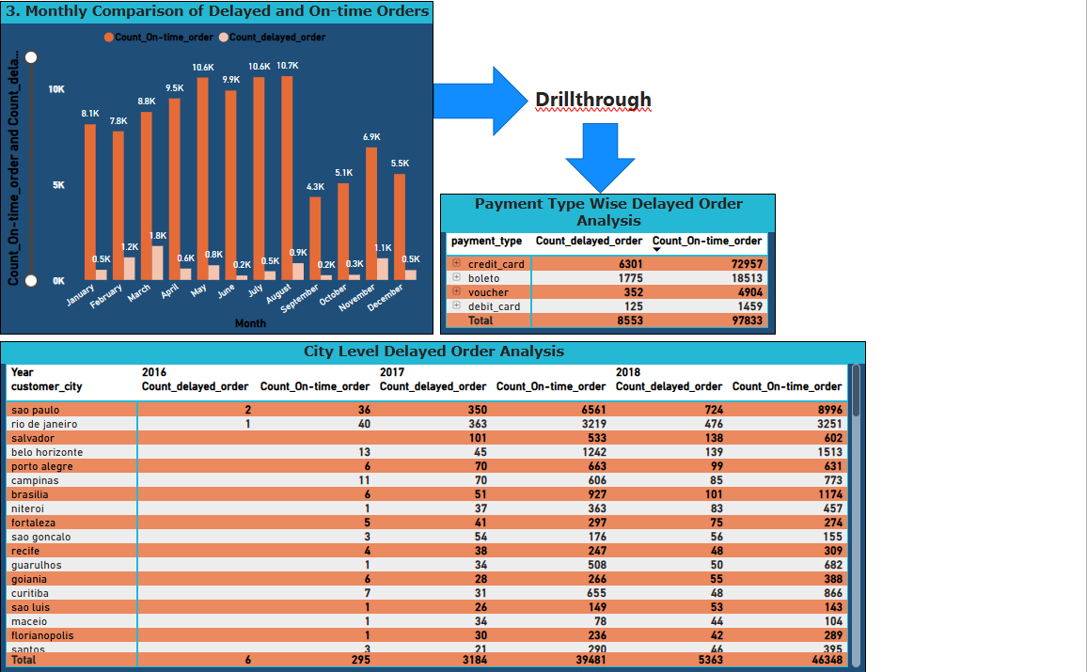

***Explanation****:* Clustered column chart depicts month-wise comparison of delayed and on-time orders. Furthermore, drillthrough feature provides city_wise and payment_type_wise detailed analysis.

***Insights****: ﻿*

* At 10661, August had the highest Count_On-time_order. At 1774, March had the highest Count_deayed order.
* Across all 12 Month, Count_On-time_order ranged from 4339 to 10661 and Count_delayed_order ranged from 230 to 1774
* 1st quarter (Jan, Feb, March) has Highest Count_delayed_order

***Business Impact****:*

* I think there is a need to make another logistic Hub in SP and RJ state as most delayed order are from there. These states are also highest Sales generating states.

1. **Payment Method Analysis**:  
   **Question 4**: Analyze the most frequently used payment methods by customers using a visually appealing representation, such as a pie chart or other suitable visuals.

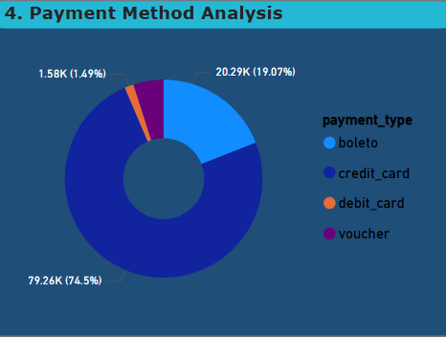

***Explanation****:* Pie-chart shows payment mode used for the payment by the customers.

***Insights****:*

* Most transactions were made by Credit card, that is, 79,258, followed by boleto, voucher, and debit_card.﻿﻿ ﻿﻿ ﻿﻿
* credit_card accounted for 74.50% of total transactions

***Business Impact****:*

* credit card transactions take **1-3 business days** to settle, potentially impacting cash flow.
* Credit cards are more prone to fraud than other payment methods, requiring robust security measures.
* businesses can negotiate lower transaction fees with banks/payment gateways.

1. **Product Rating Analysis**:  
   **Question 5**: Determine the top 10 highest-rated products and the bottom 10 lowest-rated products using a bar or column chart.

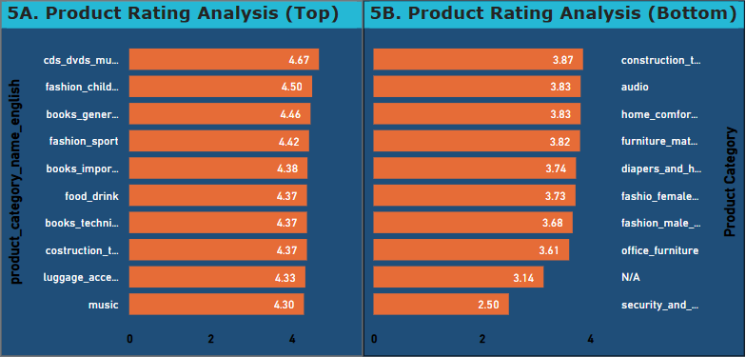

***Explanation****:* Charts depicts top 10 and bottom 10 rated product categories

***Insights****:*

* At 4.67, cds_dvds_musicals had the highest Average of review_score
* security_and_services, which had the lowest Average of review_score at 2.50.

***Business Impact****:*

* Higher customer satisfaction in cds_dvds_musicals and other categories can lead to higher trust, repeat purchases, and word-of-mouth marketing and business can leverage this as a selling point and focus on upselling and premium pricing. Expand offerings by adding **new trending editions** in top rated products**.**
* Some products need to be categorised for better upkeep of data and its analysis as N/A category has 3.14 review score
* Low rating in security_and_services and other categories suggests **customer dissatisfaction**, potentially due to poor product/service quality, delivery issues, or inadequate customer support. It can result in a **decline in sales and higher refund/return rates.**
* Improve customer support and gain market share from competitors by improving upon above mentioned issues

1. **State-wise Sales Analysis**:  
   **Question 6**: Identify and visually represent states with high and low sales, providing a clear understanding of regional sales performance.

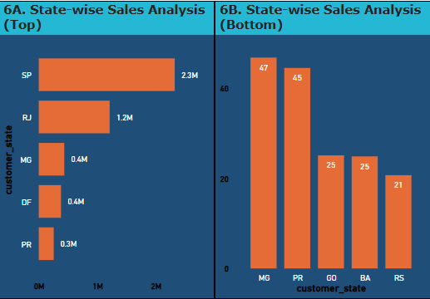

***Explanation****:*  It shows State-wise sales analysis.

***Insights****:*

* At 2.3 millions , State SP had the highest Total Sales
* State RS had the lowest Total Sales at 20.70.

***Business Impact****:*

* State SP and RJ are **key revenue drivers** and contributes significantly to overall sales. Expand further with targeted promotions and premium offerings.
* Extremely low sales indicate **poor market penetration, low demand, or operational challenges.**
* Strengthen supply chain & logistics to meet demand. Conduct **market research** to understand demand gaps. Run **localized marketing campaigns** and offer state-specific promotions because bottom states presents an untapped market. Small increase in market penetration can significantly improve total revenue.

1. **Seasonal Sales Patterns**:  
   **Question 7**: Investigate and visualize any seasonal patterns(Quarterly) or trends in sales data over the course of the year.

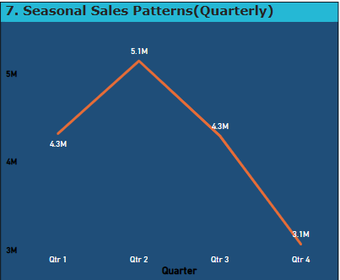

***Explanation****:* Line chart depicts seasonal trend of sales data quarterly.

***Insights****:*

* Year 2016 has limited data in which sales increased from Q3 to Q4.
* In year 2017, sales showed **consistent growth from Q1 to Q4**, indicating a strong and improving market presence.
* In 2018, sales increased slightly from Q1 to Q2 but steeply declined by 38% in Q3 signaling possible operational or market-related issues.

***Business Impact****:*

* Loss of revenue and lower profit margins
* Potential overstocking or understocking issues.
* Increased customer churn due to dissatisfaction or pricing issues.
* Identify Root Cause:product demand, competitor performance, and external factors,
* Strengthen Supply Chain
* Customer Feedback Analysis

1. **Revenue Analysis**:  
   **Question 8**: Determine the total revenue generated by ShopNest Store and analyze how it changes over time(Yearly). Represent this information through suitable visuals to highlight trends and patterns.

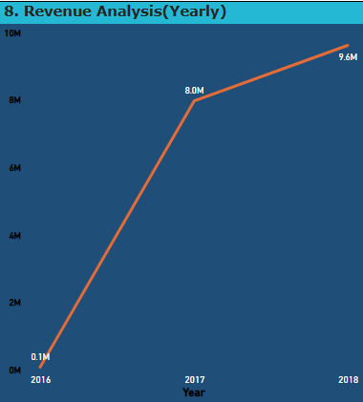

***Explanation****:* Yearly total revenue generated

***Insights****:*

* ﻿Total revenue trended up, resulting in a 14900% increase between 2016 and 2018.

***Business Impact****:*

* Expand into new markets or customer segments to sustain revenue increase.
* Optimize supply chain and fulfillment operations to handle growing demand efficiently.
* Diversify product/service offerings to prevent reliance on a single category.
* Leverage data-driven decision-making (e.g., customer behavior insights, sales forecasting).
* Prepare for scalability challenges, including staffing, logistics, and customer service improvements.  
  Keep an eye on competitor responses and market changes to adapt strategies accordingly.